Watershed Watch of Calaveras
Monitoring How-To Guide
If you have any additional questions not answered here, call Erin at (530)680-0662
Monitoring Kit Inventory
- Multiparameter | - Probe | - Data sheets on clipboard
- Pens/pencils | - Water bottle | - Trash Bag

Step One
Ensure all items are in monitoring kit.
Step Two
Carefully, connect probe to multiparameter and lock into place.
Step Three
Carefully, remove metal casing on probe to get access to the sensors. Locate the pH sensor (red base) and remove the white/clear plastic cover. Place this cover somewhere safe as to not lose it.
Step Four
Using the water bottle, rinse the sensors thoroughly and put the metal casing back on the probe. Do not use all of the water, as you’ll need to rinse the sensors again after data is collected.
Step Five
Turn on the multiparameter by pressing the red button. Place the probe in the water and let calibrate for approximately 5 minutes. Ensure the screen shows “Probe Status”. (see photo below)
Note: When placing the multiparameter in the water, do your best to put it in the middle of the flow, upstream of where you are standing and suspended in the water, not touching the streambed, branches, rocks etc.
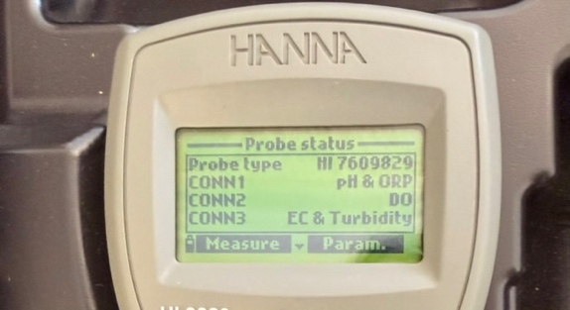
Step Six
While probe is calibrating in the stream, fill out the following on the Water Monitoring Data Sheet and take photos of the site/area. When taking photos, please capture at least upstream, downstream and the opposite bank.
- Date | - Time of Observation | - Location
- Data Collector Names | - Width of Stream | - Weather Conditions
- Site Observations | - Other Observations | - Plant species
- Animal Species

Step Seven
Begin collecting data by selecting “Measure”. pH will be displayed first, collect this measurement, record it on the data sheet, then navigate to the following parameters (%DO, ppmDO, FNU or NTU and *C).
If collecting data with more than one person, assign one person as the data “collector” and the other as the data “recorder”. When the collector says a number, the recorder should repeat the number back before writing it down to ensure it is recorded correctly
Note: to navigate the multiparameter, use the up-down arrows and the selection buttons. (see photo below)
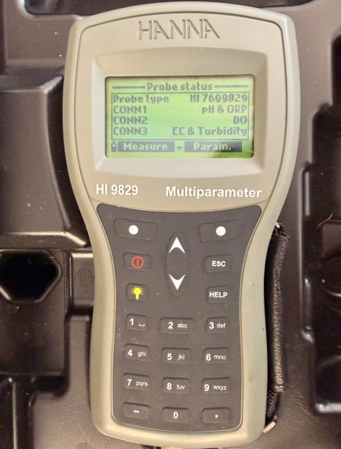
Step Eight
Move the probe to a different spot within the stream within 5ft of the original location. Wait approx. 2 minutes or until any kicked-up sediment dissipates. Repeat Step Seven. Then repeat this step once more until Data Collection is completed
Step Nine
Turn off multiparameter. Remove metal casing again and rinse sensors with water from water bottle. Put plastic cover back onto the pH sensor and put metal casing back on.
Step Ten
Ensure data sheets are filled out correctly, pack up monitoring supplies and send all photos taken to Erin (530) 680-0662 or elivernois@calaverasrcd.org.

You’re done!! Thank you for your participation in Watershed Watch of Calaveras!

Unless previous accommodations have been made, please return all equipment and monitoring kits to the CCRCD office at 423 E. Saint Charles St. San Andreas, CA 95249, next to the SAMM gas station.

