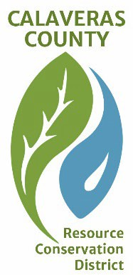
CALAVERAS COUNTY RESOURCE CONSERVATION DISTRICT
PO Box 1041  423 E. St Charles St.  San Andreas, CA 95249 info@CalaverasRCD.org

REGULAR MEETING AGENDA
Tuesday 16 June 2026, 11:00 AM

LOCATION
Murphys Fire Dept. Training Room: 58 Jones St, Murphys, CA 95247
This is an in person meeting only
In compliance with the Americans with Disabilities Act (ADA), if you need assistance to participate in the meeting, please contact the District Secretary at 743-8799 at least 48 hours prior to the start of the meeting.

CALL TO ORDER: 11:00 a.m.
- Roll Call

PUBLIC COMMENT:
The Board of Directors is limited by State law to providing a brief response, asking questions for clarification, or referring a matter to staff when responding to items not listed on the agenda.

BUSINESS:
- Approval of 10 February 2026 Minutes – Tryon – Action
- Update on Logo creation – All Committee – Information
- Trainings: S112 (chainsaws)/S211 (Pumps) by Good Fire Org – Tryon – Information
- Update on possible early fall burn locations – All Committee – Information
- Funding Opportunities
- Committee Mission and Vision
  - Technical Assistance for Prescribed Burns
  - Assist with Vegetation Management Plans
  - Maintenance of Fuel Breaks
  - Defensible Space Education & Assistance
    - Walter Tryon/Kaylee Tanner certified for Defensible Space Assessments
- Next Meeting: 18 August at 11:00

ADJOUNMENT:

